

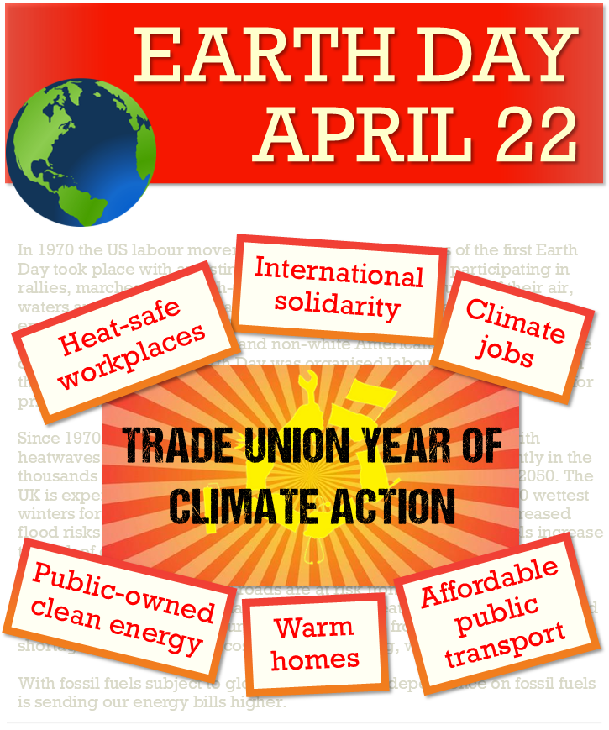
In this trade union year of climate action, Earth Day is an opportunity to take climate action in our workplaces and support local and national campaigns.
Union details here + logo

Find out more: cacctu.org.uk/yoa

